**Final Project Report**

Corrections:

1. USE CASE Diagram- shift admin to the right and students & instructors to the left. Also, login verification
2. Class Diagram – not visible and make changes as per as your website.
3. Sequence Diagram – verification needed and add if else loop.
4. USE CASE specifications – submit again by changing as per as your website.
5. At the last page of our report, our works are mentioned who did what our TA told me to inform you about it since I did almost 85% of the project work.
6. Git link - https://github.com/Nahin3426/CSE327_LMS_Project.git

# DESIGN SECTION

USE CASE DIAGRAM

Changes made are when student or instructor logins verifications is being added with include and exclude messages.

UML CLASS Diagram

Many classes were obstructed and is made clearer to read.

SEQUENCE Diagram

Changes verification is added and if else loop is added.

**\*\*IMPORTANT NOTE\*\***: the assignment and quizzes will be handled by instructor and students privately, but the instructor must submit those documents properly to LMS for clarification of results and grades. This is why, in the sequence diagram it is mentioned and in case diagram it is mentioned in admin manages document issues. Just like how an university handles its students, similarly our LMS will also handle our students similar to it.

USE CASE SPECIFICATION

**1.Administration**

Use Case Name: System Administration

Actor: System Administrator

Scenario/Description:

Scenario: John, the system administrator, needs to perform various administrative tasks within the Learning Management System (LMS).

Description: John logs into the LMS administrative dashboard using his username and password. Upon successful authentication, he gains access to a range of administrative functionalities.

1. Authentication:

- John enters his username and password into the login screen.

- The system validates the credentials against the stored user data.

- If the credentials are correct, John is granted access to the administrative dashboard.

- If the credentials are incorrect, John receives an error message and is prompted to re-enter his login details.

2. Managing Courses:

- Once logged in, John can manage courses offered within the LMS.

- He can create new courses, update existing course details, or deactivate courses that are no longer active.

- John ensures that course information, such as titles, descriptions, and instructors, is accurate and up to date.

3. Enrolling Students:

- John has the authority to enroll students in courses.

- He can add new students to the system and assign them to appropriate courses based on their academic requirements.

- John verifies student enrollment requests and ensures that students are properly registered for their chosen courses.

4. Navigating Instructors:

- As part of his administrative duties, John oversees the instructor roster.

- He can view a list of instructors associated with each course and their contact information.

- John communicates with instructors regarding course schedules, curriculum updates, and any administrative matters.

5. Managing System:

- John is responsible for maintaining the overall functionality of the LMS.

- He monitors system performance, troubleshoots technical issues, and implements updates or patches as needed.

- John ensures that the LMS operates smoothly and efficiently to support the teaching and learning activities of the institution.

6. Collecting Payment:

- In cases where courses have associated fees, John facilitates payment collection from students.

- He oversees payment processing, ensuring that transactions are secure and properly recorded.

- John monitors payment statuses and addresses any discrepancies or outstanding balances.

Exception:

- If there are technical issues preventing John from accessing the administrative dashboard or performing administrative tasks.

- If John attempts to perform actions outside his administrative privileges, such as modifying sensitive system settings without proper authorization.

Precondition:

- John has administrative privileges and a valid login account for the LMS.

- The administrative dashboard is accessible and functional.

- John has the necessary information and resources to carry out administrative tasks effectively.

Postcondition:

- Administrative tasks are executed successfully, ensuring the smooth operation of the LMS.

- Changes made by John are recorded and reflected in the system logs for auditing purposes.

- The LMS remains secure, stable, and conducive to the teaching and learning activities of the institution.

**2.Student**

1. Use Case Name: Accessing Course Materials

2. Actor: Student

3. Scenario/Description:

- Scenario: John, a student, wants to access the course materials for his biology class.

- Description: John logs into the Learning Management System (LMS) using his student credentials. He navigates to his biology course and clicks on the "Course Materials" tab. John is presented with a list of available materials, including lecture slides, reading assignments, and supplementary resources. He selects the materials he needs and begins studying the content.

4. Exception:

- If there are technical issues with the LMS, preventing access to course materials.

- If the course materials are not properly uploaded or are incomplete.

5. Precondition:

- John has a valid student account for the LMS.

- The biology course is available in the course catalog.

- John is enrolled in the biology course.

6. Postcondition:

- John has successfully accessed the course materials for his biology class.

- He can now study the materials at his convenience and proceed with the course curriculum.

**3.Instructor**

1. Use Case Name: Creating and Managing Course Content

2. Actor: Instructor

3. Scenario/Description:

- Scenario: Professor Smith wants to create and manage course content for his physics class.

- Description: Professor Smith logs into the LMS using his instructor credentials. He navigates to the "Course Management" section and selects his physics course. Professor Smith can create new modules, upload lecture slides, videos, and reading materials, and adjusts course content as needed.

4. Exception:

- If there are technical issues preventing Professor Smith from accessing the course management section or uploading course content.

- If the LMS lacks necessary features or tools for creating and managing course content effectively.

5. Precondition:

- Professor Smith has a valid instructor account for the LMS.

- The physics course has been created and is available in the course catalog.

- Access to the course management features and tools is available.

6. Postcondition:

- Professor Smith has successfully created and managed course content for his physics class.

- Students enrolled in the course can access the materials and assignments created by Professor Smith.

**4.Courses**

1. Use Case Name: Enrolling in Courses

2. Actor: Student

3. Scenario/Description:

- Scenario: Mark, a student, wants to enroll in a computer science course.

- Description: Mark logs into the LMS using his student credentials. He navigates to the course catalog and browses through the available courses. After finding the computer science course he's interested in, Mark clicks on the course to view more details. He reviews the course description, prerequisites, and instructor information. If the course meets his requirements, Mark clicks on the "Enroll" button. After confirming his enrollment, Mark receives a confirmation message and is added to the roster of students for the course.

4. Exception*

- If there are technical issues preventing Mark from accessing the course catalog or enrolling in the course.

- If the course is already at full capacity, and no additional enrollments are allowed.

5. Precondition:

- Mark has a valid student account for the LMS.

- The computer science course is available in the course catalog.

- Enrollment is open for the course, and there is available space.

6. Postcondition:

- Mark has successfully enrolled in the computer science course.

- He gains access to the course materials, assignments, and communication channels associated with the course.

**5. Certificate Class**

Use Case Name: Generating Certificates

Actor: System Administrator

Scenario/Description:

Scenario: Professor Lumina, an instructor, needs to generate certificates for students who have successfully completed the "Introduction to Programming" course.

Description: Professor Lumina logs into the LMS administrative dashboard and navigates to the certificate generation section. She selects the "Introduction to Programming" course from the list of completed courses and chooses the students who have met the requirements for certification. Professor Lumina then initiates the certificate generation process, and the system automatically generates certificates for the selected students. Each certificate includes the student's name, course title, completion date, and any other relevant information. Once the certificates are generated, Professor Lumina can download them in PDF format or distribute them electronically to the students.

Exception:

- If there are technical issues preventing Professor Lumina from accessing the certificate generation section or initiating the certificate generation process.

- If the course completion data is incomplete or inaccurate, resulting in incorrect certificates being generated.

Precondition:

- Professor Lumina has administrative privileges and a valid login account for the LMS.

- The "Introduction to Programming" course has been completed, and students have met the requirements for certification.

- Access to the certificate generation section of the LMS is available, and the system is functioning properly.

Postcondition:

- Certificates are successfully generated for students who have completed the "Introduction to Programming" course.

- Each certificate accurately reflects the student's achievement and includes relevant course details.

- Professor Lumina can download the certificates and distribute them to the students, acknowledging their successful completion of the course.

**6. Use Case Name: Course Payments**

Actor: Student

Scenario/Description:

- Scenario: Alex, a student, needs to pay for his upcoming psychology course.

- Description: Alex logs into the LMS and navigates to the "Payments" section. He selects the psychology course from the list of available courses and proceeds to the payment gateway. Alex enters his payment details, such as credit card information or other payment methods supported by the LMS. He confirms the transaction, and the payment gateway processes the payment securely. Once the payment is successful, Alex receives a payment confirmation and is officially enrolled in the psychology course.

Exception:

- If there are technical issues with the payment gateway, preventing Alex from completing the transaction.

- If Alex's payment method is declined or encounters issues during processing.

Precondition:

- Alex has a valid student account for the LMS.

- The psychology course is available for enrollment.

- Access to the payment section of the LMS is available, and the payment gateway is functioning properly.

Postcondition:

- Alex has successfully made the payment for the psychology course.

- He is officially enrolled in the course and gains access to course materials, assignments, and other resources associated with the course.

WEBSITE (only showing Home and Login page)

Home Page



Login page

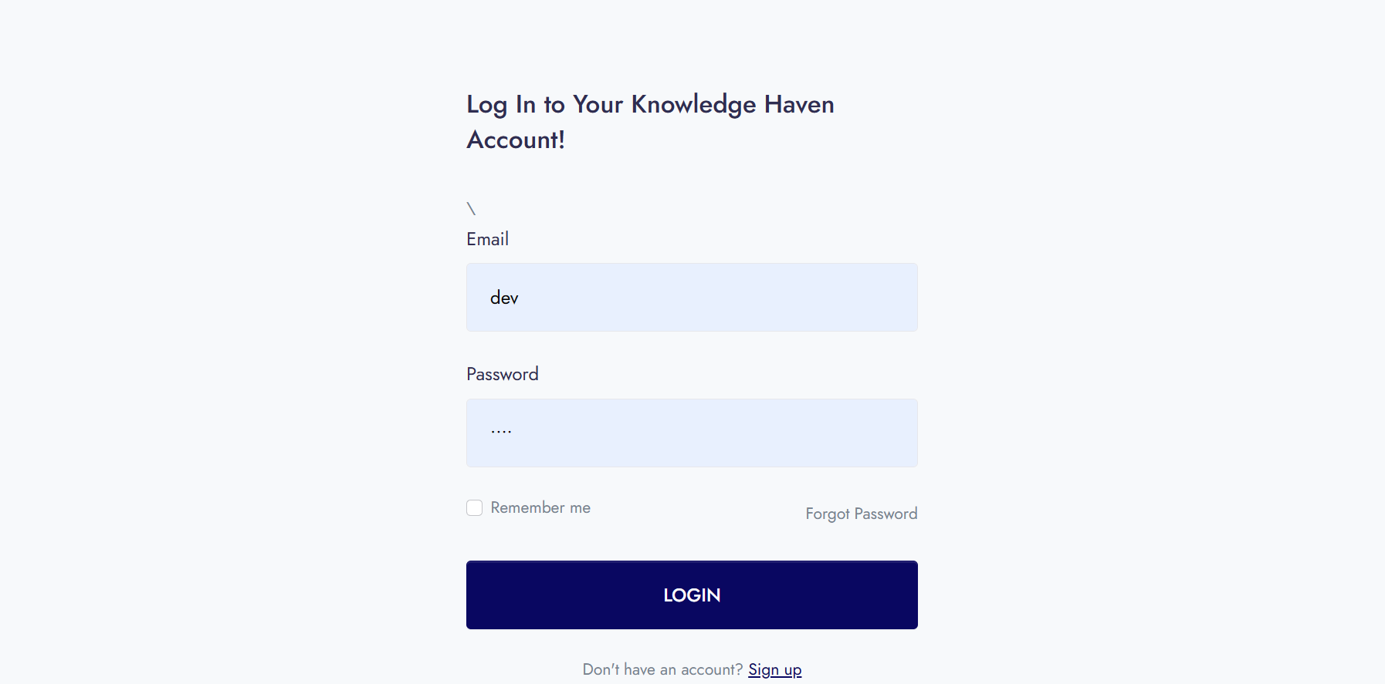

Team Binary Bandits

1. Mohammad Nahin Islam 2013356042- fronted (all except about_us.html and login.html), backend (all), design (use case diagram, class diagram)
2. Khandoker Tanim 2021655642 – frontend (about_us.html and login.html)

1. Nazmoon Nahar Tisha 1921989642- design (only sequence diagram)